DAILY ONLINE ACTIVITIES SUMMARY

|  |  |  |  |  |  |  |  |
| --- | --- | --- | --- | --- | --- | --- | --- |
| **Date:** | **17-06-2020** | | | | **Name:** | **Kavya.R.Shetty** | |
| **Sem & Sec** | **6th sem, ‘A’ sec** | | | | **USN:** | **4AL17CS042** | |
| Online Test Summary | | | | | | | |
| **Subject** | | 1. **Programming in C** 2. **Applications of Python Programming in DA and ML** | | | | | |
| **Max. Marks** | | **-** | | **Score** | | **-** | |
| Certification Course Summary | | | | | | | |
| **Course** | Workshop on “**Applications of Python Programming in DA and ML”** | | | | | | |
| **Certificate Provider** | | | **-** | **Duration** | | | **-** |
| Coding Challenges | | | | | | | |
| **Problem Statement:1 Python program** | | | | | | | |
| **Status: executed** | | | | | | | |
| **Uploaded the report in GitHub** | | | | **Yes** | | | |
| **If yes Repository name** | | | | <https://github.com/kavya-shetty765/DAILY-> [STATUS](https://github.com/nandithashetty/DAILY-STATUS) | | | |
| **Uploaded the report in slack** | | | | **Yes** | | | |

# Online Test Details:

Programming in C

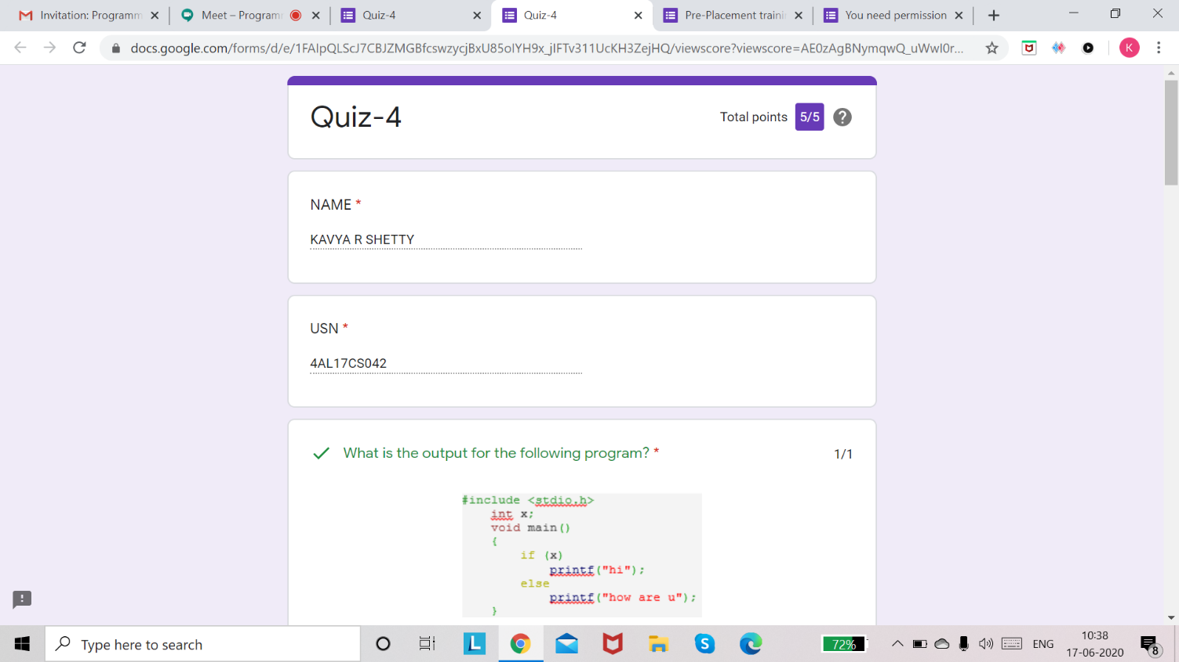

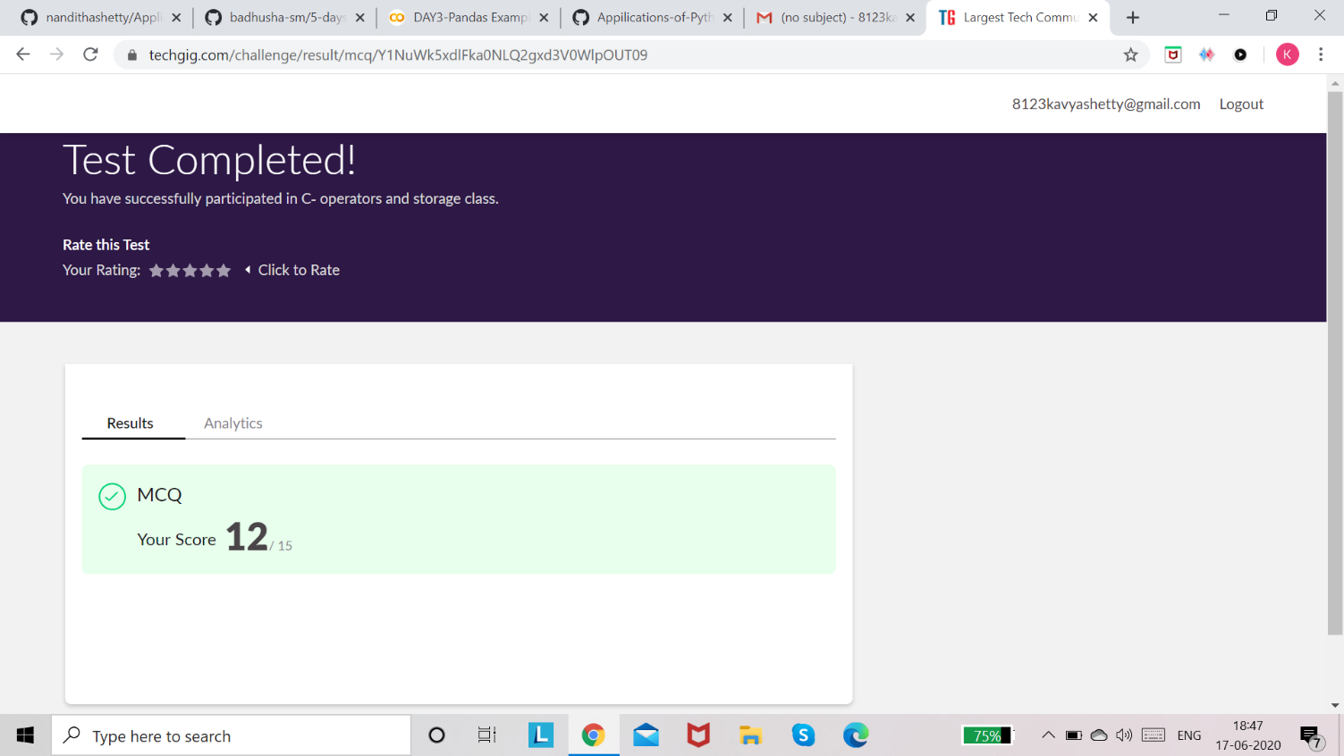

# Certification Course Details: (WORKSHOP)

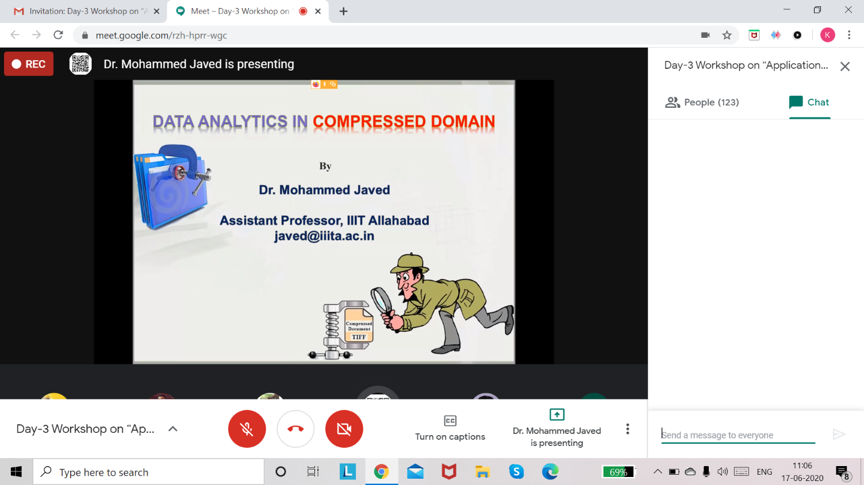

**Coding Challenges Details:**

Program 1

## **Find the smallest positive integer value that cannot be represented as sum of any subset of a given array sorted in ascending order**

Program2

## **Write a Java program to find the row, column position of a specified number (row, column position) in a given 2-dimensional array**

# Workshop on “Applications of Python Programming in DA and ML”

Today’s exercise uploaded in :-

<https://github.com/kavya-shetty765/Appilications-of-Python-Programming-in-DA-and-ML>

This Report is also available in:

<https://github.com/kavya-shetty765/DAILY-STATUS/tree/master/17-06-2020>